**GROUP PROJECT, GROUP 3**

**DATE: 06th December 2018**

**TIME: 13:00 – 19:00**

**ATTENDEES** Henry Crofts, Tom Gibbs

**LOCATION:** Common Room, Atrium

**Minute Taker: Henry Crofts**

**Overall aims of the current sprint *(Detailed tasks, user stories and time allocations are tracked on JIRA)***

* Review completed tasks from previous sprint
* Identify subsequent tasks for this sprint, negotiate allocation of tasks
* Confirm team availability this sprint to ensure 2 full-day studio-jams
* Work towards setting up the pitch presentation ready for Monday 10th December

**Meeting:**

Both Present

The team met with Rob to discuss the presentation where Rob reiterated what was discussed during the Monday Group meeting going over

* Show before telling
* Explain where we are, where we plan to be after Christmas, our plan to MVP
* Include screenshots and videos of X minutes with explanations into what is currently happening.
* Expand on the psychographic and link these to the features and design choices

Rob also went over some new points that might be more specific to our game such as;

* Read the comments and reviews on competitor’s games
  + Find out how they achieve their learn-practice-master loop and what players enjoyed about these games.
  + Hard fun is a core pleasure.
  + Use the reviews and feedback on these sites and let it influence the psychographic.
* It doesn’t matter if people don’t like the game it’s only important that the game is designed for the psychographic and that they enjoy the game.
* Tutors want to see that the psychographic is informing the design choices made in the game.

After meeting with Rob, team continued to work on Tom’s task of player ID together, the different techniques used include;

* Custom shaders to show the circle and fill it up to show player task completed
  + This technique worked well, however whenever the player went up ramps and other raised platforms the ID circle would go through the floor hiding it from the player when in those situations.
* Projector using a shader
  + Using techniques from the above shader we tried using the projector, which seemed like it would work well, however when the shader was applied to the projector, the projector would project over the whole scene causing some strange results, this was unexpected and could not be resolved.
* Using Raycasting to rotate a UI canvas element
  + We tried using the UI canvas to place a circle sprint underneath the player, which again seemed like it would do well, however this acted in a similar method to the first point about custom shaders.
* Multiple cameras
  + Used three cameras, one for UI, Player and the ship model, however this caused the player to be drawn last, placing him on top of objects that he should have been behind, and no shadows being cast in the scene.
* Projector Only
  + Eventually we were able to figure out a way to use the projector on its own, having two projectors, one for the outer ring, and a second solid circle on that would start in the middle and expand outwards, although we wanted a circular fill out like a clock hand spinning round however we had spent a lot more time than was allocated to this task and needed to move on.

While Tom was finishing off the projector player ID Henry spent time making the enemy cannonball pre-hit marker using a different projector

***Detailed tasks, task descriptions, user stories and time allocations are tracked on JIRA.***

**Tasks for the current week:**

**Tom (11 Hours 30mins):**

* **Rehearse presentation (2h)**

Once the presentation has been fully adjusted with the new content, spend time in A2.07 (or another free room) and rehearse individual parts of the presentation with Henry.

* **Adjust presentation with Henry (3h)**

Spend time going through the presentation, working out which slides need updating with the latest build of the game and which slides will need to be completely changed. Make these adjustments with Henry in a studio-jam style.

* **Model Fire Pit (2h)**

Model a fire pit to go at the end of the boat for the torch to spawn in. Design will be discussed on Tuesday 4th December.

* **Crow’s Nest UI (1h 30m)**

Animate a textbox that scrolls out as we have mentioned in previous meetings and create the textbox / sprites that will be used as “content” for the UI speech bubble.

* **Player ID (3h)**

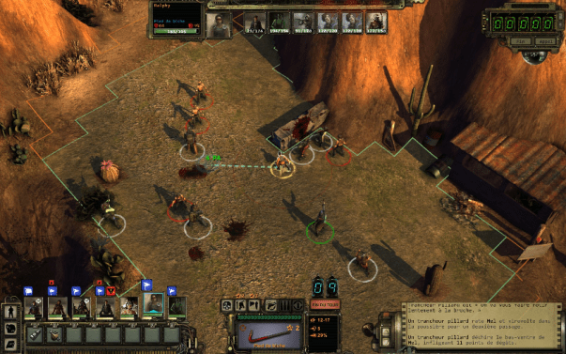Explore different techniques that can be used to show the player ID as a ring around the players feet, so each player will know who they are controlling, reference pictures such as where each player has a ring around them, investigate using *Shaders* and *Projectors*.

**Henry (12 Hours 30 mins):**

* **Rehearse presentation (2h)**

Once the presentation has been fully adjusted with the new content, spend time in A2.07 (or another free room) and rehearse individual parts of the presentation with Tom.

* **Adjust presentation with Tom (3h)**

Spend time going through the presentation, working out which slides need updating with the latest build of the game and which slides will need to be completely changed. Make these adjustments with Henry in a studio-jam style.

* **Cannon status UI (1h 30m)**

Implement the UI for the cannon to show the player when the Gunpowder and/or Cannonball is loaded, once both items are loaded in, swap the sprites out to show a torch.

* **Update the enemy flag to work for the presentation (2h)**

Fix and update the enemy flag to show the correct position of the enemies in preparation for the presentation.

* **Update the enemy cannons to work for the presentation (2h)**

Fix the cannon hit placement to show the correct location where the cannonball is going to land on the player’s boat.

* **Complete repair deck script (2h)**

Complete the script that allows the player to pick up a plank of wood and take it to a damaged section of the ship and repair it.